1. Find all the information about each products

db.products.find()



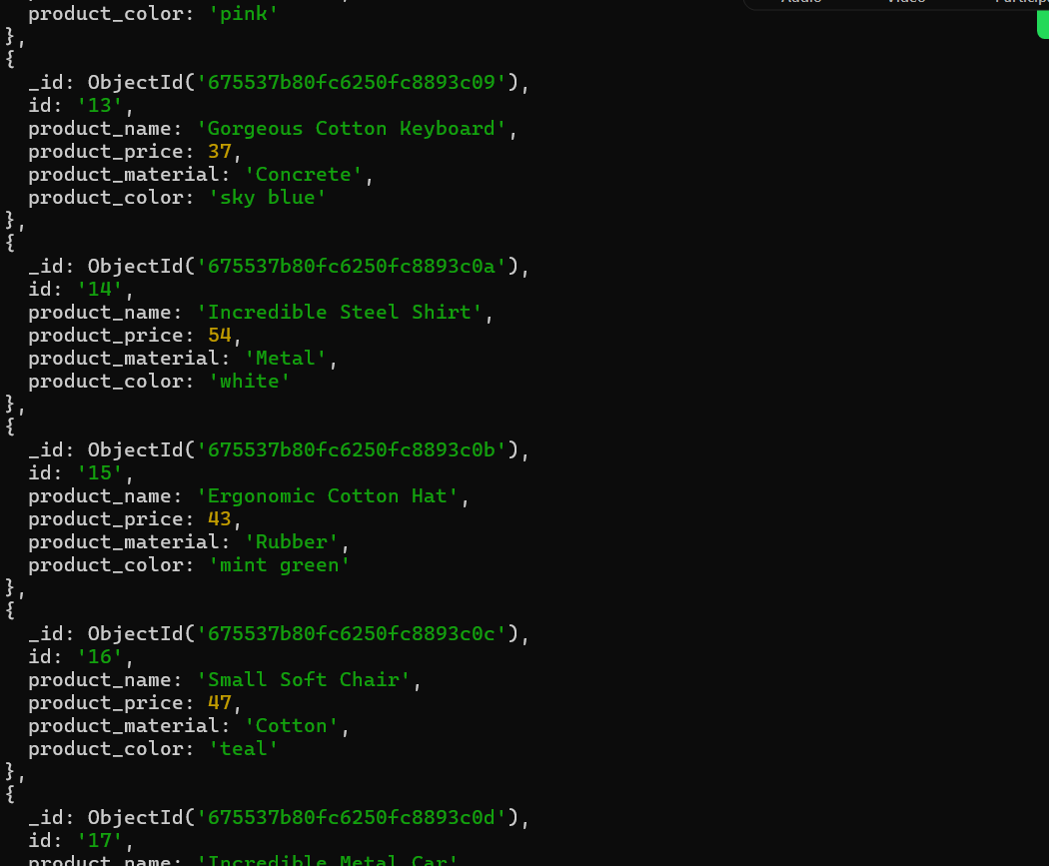

2. Find the product price which are between 400 to 800

db.products.find({product_price: {$gte:400, $lte:800}})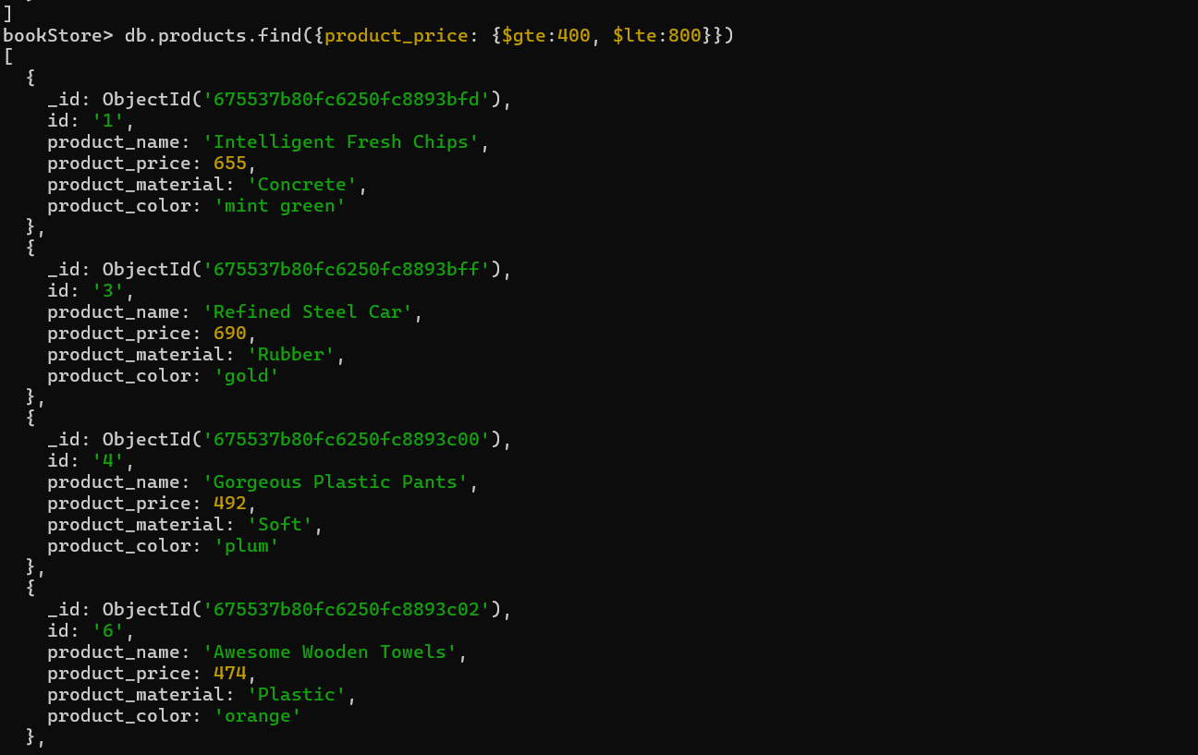

3. Find the product price which are not between 400 to 600

db.products.find({product_price: {$not: {$gte:400, $lte:600}}})

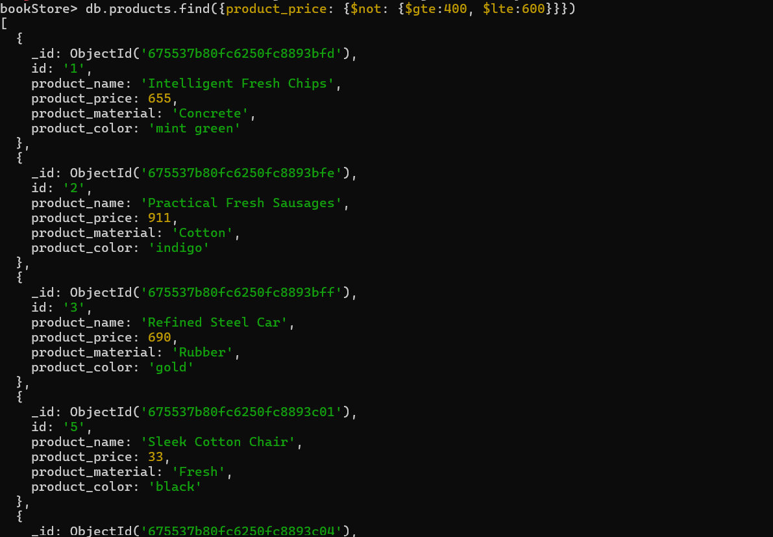

4. List the four product which are greater than 500 in price

db.products.find({product_price: {$gt: 500 }}).limit(4)

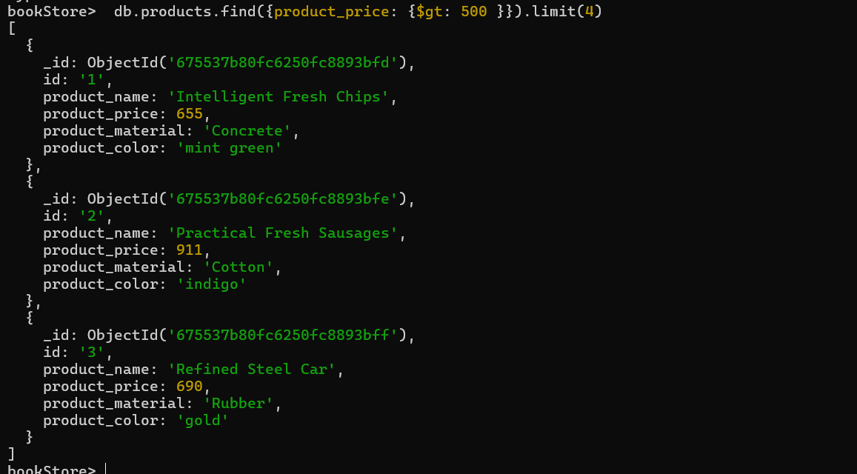

5. Find the product name and product material of each products

db.products.find({}, {product_name: 1, product_material:1, _id:0}).pretty()

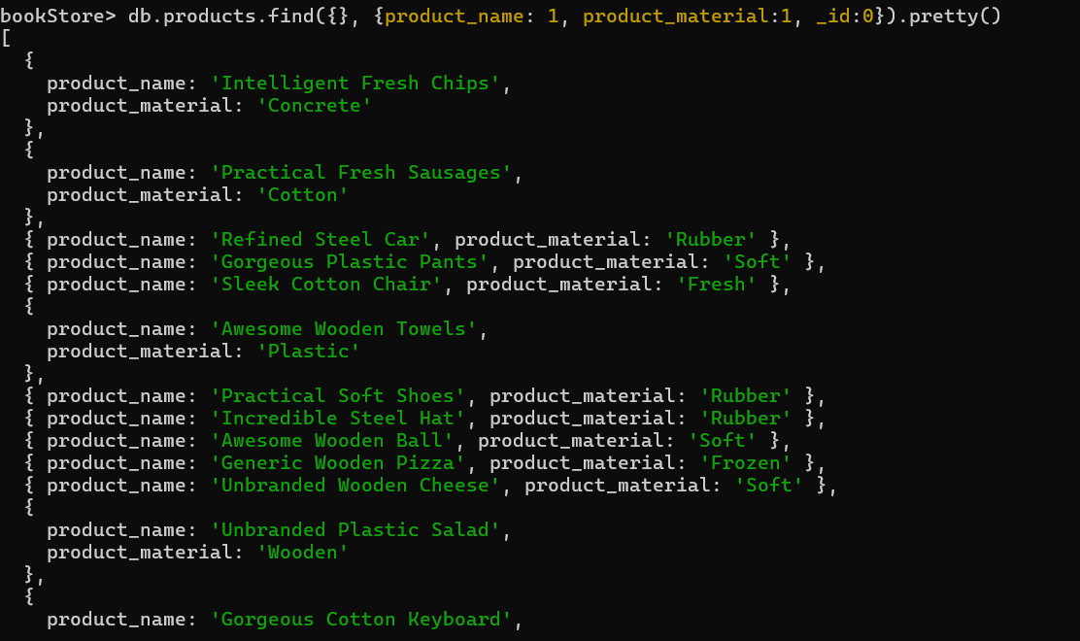

6. Find the product with a row id of 10

db.products.find({id:'10'})

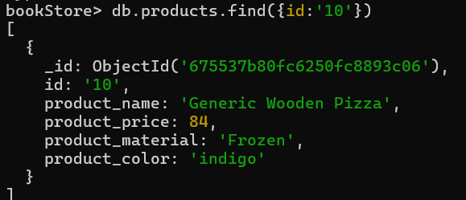

7. Find only the product name and product material

db.products.find({}, {product_name: 1, product_material:1, _id:0}).forEach(doc => {print(`Product Name: ${doc.product_name}, product_material: ${doc.product_material}`)})

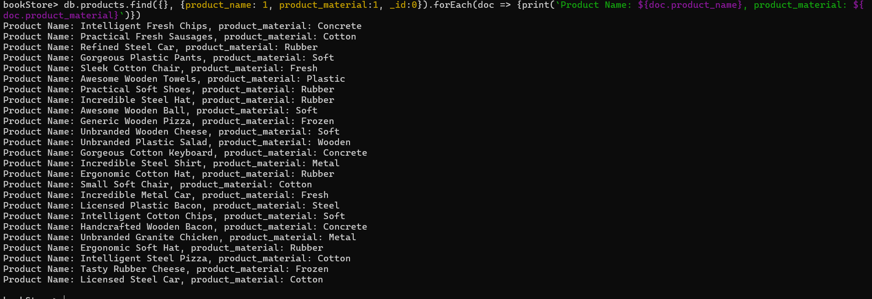

8. Find all products which contain the value of soft in product material

db.products.find({product_material: {$eq:"Soft"}})

OR

db.products.find({product_material: { $in : ["Soft"] }})

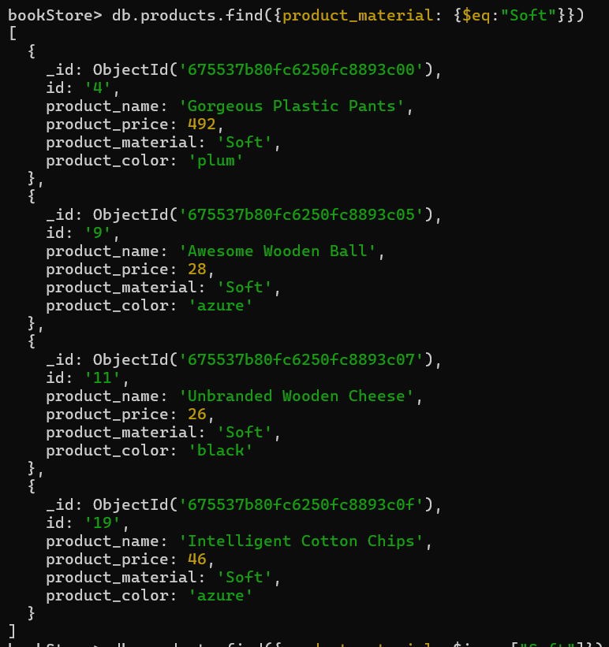

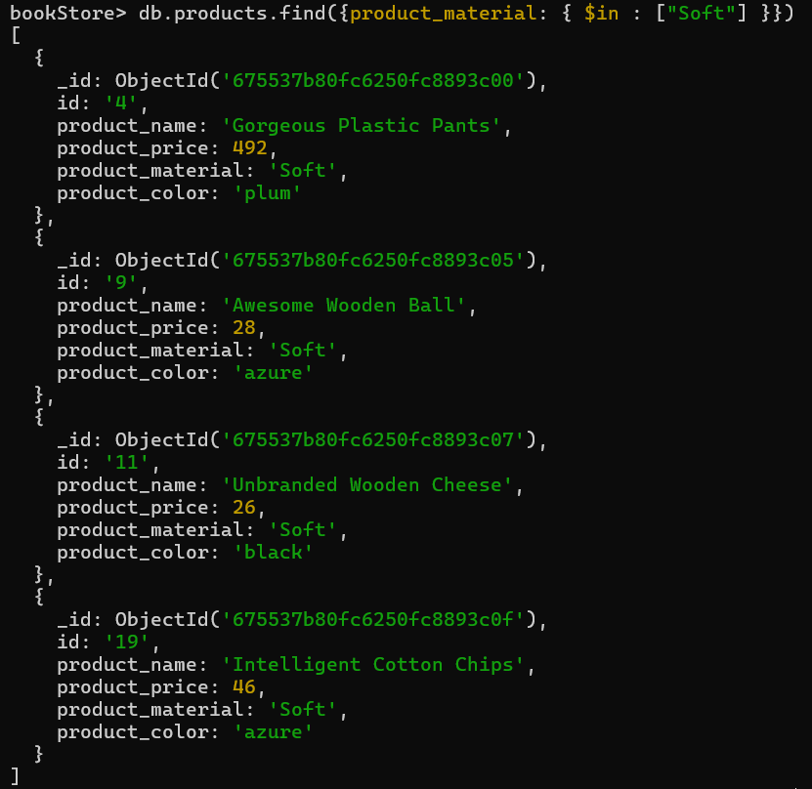

9. Find products which contain product color indigo and product price 492.00

db.products.find({ $and: [{product_color: "indigo"},{product_price: 492.00}]})

db.products.find({ $or: [{product_color: "indigo"},{product_price: 492.00}]})

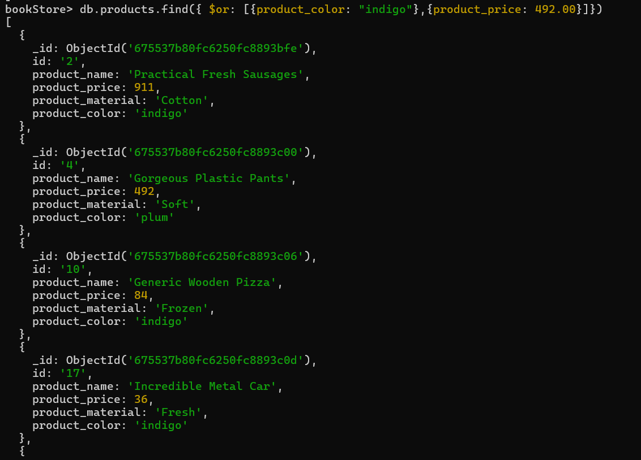

10.Delete the products which product price value are 28

db.products.deleteMany({product_price: 28})

